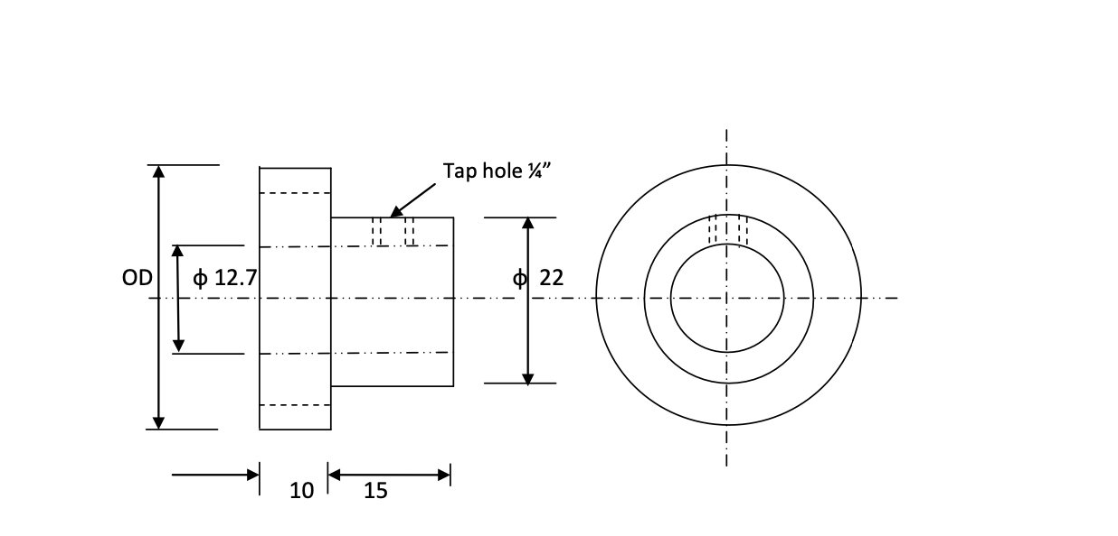

Quantity = 2

No. of teeth = 20

Module = 1.5

OD = 33

Rod Diameter = 12.7

Depth of cut = 2.157 *7

Tap hole size = ¼”

Indexing = 2

|  |  |
| --- | --- |
| **Part name:** Spur gear | |
| **Quantity:** 2 | **Scale:** 1:2 |
| **Material Required:** Metal | |